[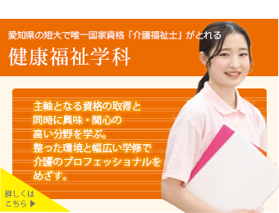](https://www.jc.nagoya-su.ac.jp/department/health)